
837 West Shaw St., P.O. 688, Howard City, MI 49329
P: (231) 937-9370 ~ F: (231) 648-6263
New Patient Information-Child 3-10
Today’s Date: _____/_____/_______
Parent/Guardian Information

Mother or Guardian Name: __________________________________ SS #: _______-_____-_______
Home Phone (_______) ____________________ Cell Phone: (_______) __________________

Father or Guardian Name: ___________________________________ SS #: _______-_____-_______
Home Phone (_______) ____________________ Cell Phone: (_______) __________________

Emergency Contact
Emergency Contact Person #1: ____________________________________ Relationship:_______________________
Home Phone: (____) _______________ Cell Phone: (____) _______________ Work Phone: (____) _______________
Emergency Contact Person #2: ____________________________________ Relationship: ______________________
Home Phone: (____) _______________ Cell Phone: (____) _______________ Work Phone: (____) _______________

Patient Information
Patient Name: _______________________________________ Nickname/Preferred Name: ____________________
Gender: M F Age: ______ DOB: _____/______/________ SS #: _________-_________-____________
Address: ________________________________________________________________________________________
City:_________________ State: ____ Zip: ________

**By supplying my home phone number, mobile phone number, email address, and any other personal contact information, I authorize my health care provider to employ a third-party automated outreach and messaging system to use my personal information, the name of my care provider, the time and place of my scheduled appointment(s), and other limited information, for the purpose of notifying me of a pending appointment, a missed appointment, overdue wellness exam, balances due, lab results, or other communications. I also authorize my healthcare provider to disclose to third parties, who may intercept these messages, limited protected health information (PHI) regarding my healthcare events. I consent to the receiving of multiple messages per day from the automated outreach and messaging system, when necessary.

May we e-mail you? Y N
Would you like appointment reminders texted to your cell phone? Y N *If yes, which number? ____________
May we leave voicemail on Home/Cell Phone: Y N **Permissions can be changed at any time upon request*

I understand the above information and guarantee this form was completed correctly to the best of my knowledge and understand it is my responsibility to inform this office of any changes to the information I have provided.
__________________________________________________________ ________/_________/_______________
Signature Date
__________________________________________________________
Printed Name
***We invite you to discuss with us any questions regarding our services. The best health services are based on a friendly, mutual understanding between provider and patient.

Insurance Information:
Do you have health insurance? Y N If yes, please fill out the information below:
Primary: Name of Subscriber: __________________________________________ DOB: _______/______/________
Name of Insurance: _________________________________________
Secondary: Name of Subscriber: _________________________________________ DOB: _______/______/________
Name of Insurance: _________________________________________
Tertiary: Name of Subscriber: ____________________________________________ DOB: _______/______/_______
Name of Insurance: _________________________________________

Health Information:
Health Concerns: (please List in priority order and use back for additional space)
- ___________________________________________________________________________________________

- ___________________________________________________________________________________________

- ___________________________________________________________________________________________

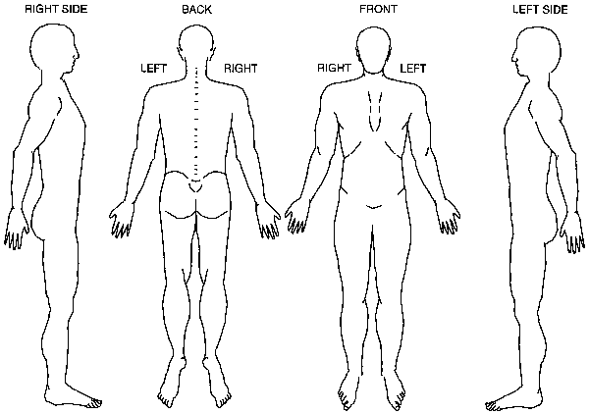
Symptoms/Complaints: (relating to primary complaints)
When did symptoms begin? ______________ What initiated symptoms?______________________________________
__________________________________________________________________________________________________
Have your child previously been treated for this condition by another provider? Y N
If yes, by whom? __________________________ Treatment received:_________________________________________
Have you had any reactions to pervious treatment? Y N Describe:_______________________________________
Has it worsened over time: Y N Same Better Worse
How long does it last? All Day Hours Minutes Other:____________________________________________
Is the problem worse during a certain time of day? Morning Afternoon Evening Night Other
Is this condition interfering with: School Sleep Daily Routine Recreation Other: _______________
Describe the symptoms (check all that apply): Dull Achy Pain Sharp Stabbing Numbness
Tingling Burning Shooting Stiffness Tightness Other: _______________________________________
What makes the problem worse? Standing Sitting Walking Bending Lifting Twisting Changing
positions Movement Other:______________________________________________________________________
Have you found things that relieve symptoms? Y N If yes, describe:______________________________________
Do you have other conditions or symptoms that may be related to current symptoms? Y N
If yes, what?________________________________________________________________________________________
Treatment: What type of treatment are you looking to receive?
Symptom Relief Correctional Care Total Wellness Care All 3 choices

Health History:
Have you had any major childhood traumas or accidents? Y N If yes, describe:_____________________________
__________________________________________________________________________________________________
Have you had any surgeries or procedures? Y N If yes, describe:_________________________________________
__________________________________________________________________________________________________
Have you had any significant childhood illnesses? Y N If yes, describe:____________________________________
__________________________________________________________________________________________________
Any childhood antibiotic use? Y N
Please list any medications that your child is currently taking, including over the counter medications: ______________________________________________________________________________________________________________________________________________________________________________________________________________________________________________________________________________________________________
Any known allergies to medication? ____________________________________________________________________
Any food intolerances or allergies? Y N If yes, list: ___________________________________________________
How is digestion? Regular bowel movements? Y N How many per day? ____________
How is sleep? How many hours at a time at night? ___________
How many hours per day of screen time? __________
Are you involved in any sports or activities? Y N If so, what sports:______________________________________
Are you getting any physical activity? Y N If so, what and how much:_____________________________________

Please mark all other applicable health related symptoms or conditions as they apply:
Headache Shoulder Pain Tingling in Hands Fainting
Facial Pain Persistent Cough Clammy Hands Convulsions
Blurred Vision Chest Pressure Low Back Pain Irritability
Dizziness Slow Heart Rate Hip Pain Impatience
Earache Rapid Heart Rate Knee Pain Feel Loss of Control
Eye Pain High Blood Pressure Poor Circulation Other: ________________________
Forgetfulness Low Blood Pressure Swollen Joints ________________________________
Confusion Abdominal Pain Joint Stiffness
Sinusitis Nausea/Vomiting Swollen Ankles *Additional (check all that apply)
Teeth Grinding Poor Appetite Ankle/Foot Pain Seizures (Epilepsy)
Dry Mouth Fullness of Bladder Tingling in Feet Transplant
Excessive Thirst Urination Difficulty Walking Problems Surgically Implanted Device
Unpleasant Taste Frequent Urination Sore Muscles Pacemaker
Neck Pain Constipation Weak Muscles
Sore Throat Hemorrhoids Paralysis
Lump in Throat Elbow/Hand Pain Shakiness
Swallowing Pain Sweating
Unsteady Voice Insomnia

Family History:
Identify conditions that your or any of your family members have now or in the past.
(G=Grandparents, M=Mother, F=Father, S=Sibling, X=Self)
_____ Allergies _____ Eczema _____ Headaches/Migraines _____ Pneumonia
_____ Alcoholism _____ Emphysema _____ HIV/AIDS _____ Stroke(s)
_____ Anemia _____ Epilepsy _____ Miscarriage(s) _____ Tumor(s)
_____ Cancer _____ Gout _____ Overweight _____ Ulcer(s)
_____ Diabetes _____ Heart Disease _____ Pleurisy _____ Addiction
_____ Other: _______________________________________________________________________________________

Please Check all that apply:
 | Light | Moderate | Heavy | None
Physical Activity
Coffee, Tea
Soda, Diet Soda
Stress Level

